- 1) Capture and analyze ARP packets using Wireshark. Inspect the ARP request and reply frames, and discuss the role of the sender's IP and MAC address in these packets.
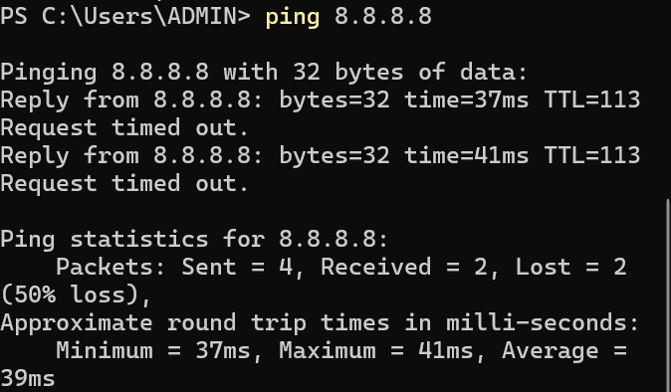
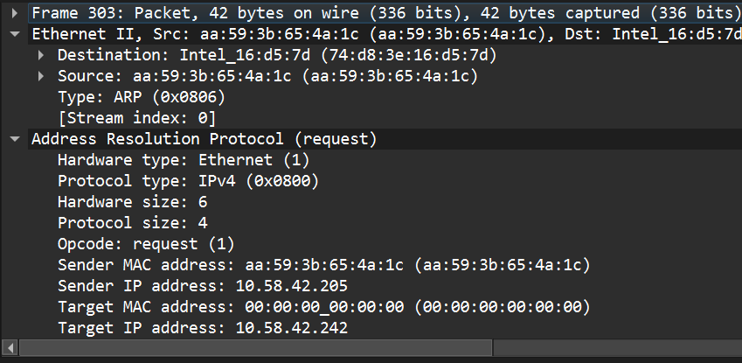
ARP packets help devices discover MAC addresses within a LAN. The ARP request contains the sender's IP and MAC address and asks for the MAC address of a target IP. The ARP reply provides the requested MAC address. This process allows devices to map IP addresses to MAC addresses and communicate efficiently within the local network.
The Sender IP Address identifies the device requesting or replying.The Sender MAC Address provides the physical address required for communication inside the local network.In an ARP request, the sender broadcasts its IP and MAC so the target device knows where to send the reply. In the ARP reply, the sender includes its MAC address so the requesting device can store it in the ARP table and communicate directly.
2) Using Packet Tracer, simulate an ARP spoofing attack. Analyze the behavior of devices on the network when they receive a malicious ARP response.
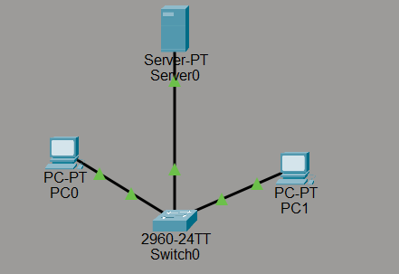
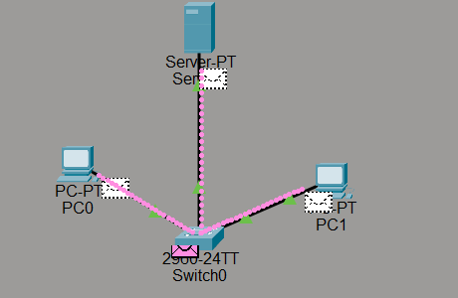

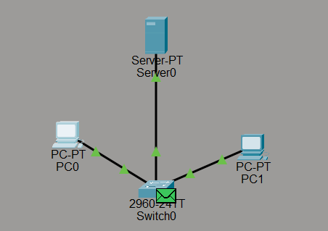
ARP spoofing is an attack where a malicious device sends fake ARP replies to associate its MAC address with another device’s IP address. In the Packet Tracer simulation, the attacker tricks the victim device into updating its ARP table with incorrect information. As a result, network traffic is redirected to the attacker instead of the intended device.
3) Manually configure static IPs on the client devices(like Pc or your mobile phone) and verify connectivity using ping.
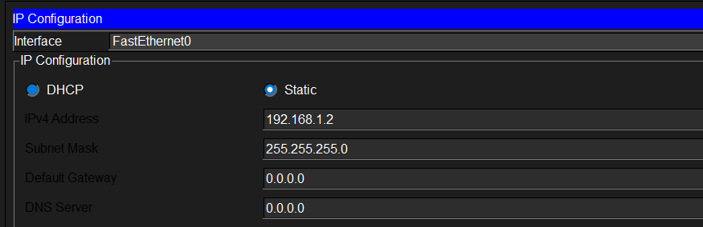
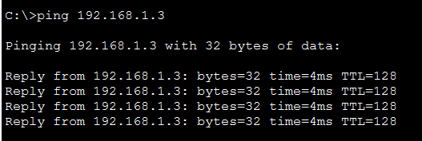
Static IP addresses were manually configured on the client devices using the IP configuration settings. Each device was assigned a unique IP address within the same network. After configuring the addresses, connectivity was tested using the ping command. The successful reply messages confirmed that the devices were able to communicate with each other over the network.
4) Use Wireshark to capture DHCP Discover, Offer, Request, and Acknowledge messages and explain the process.
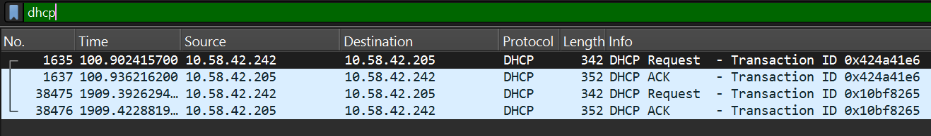
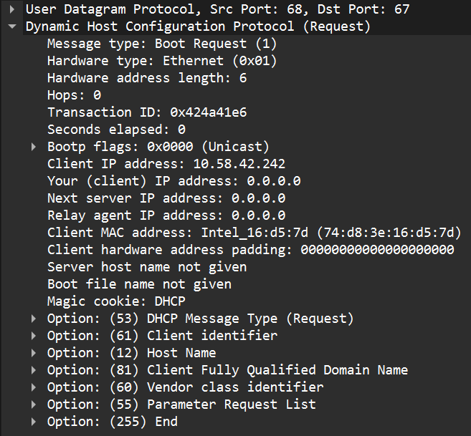
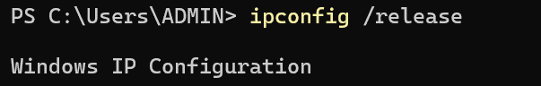
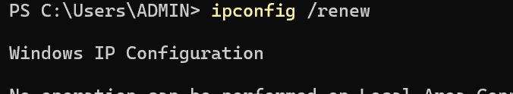
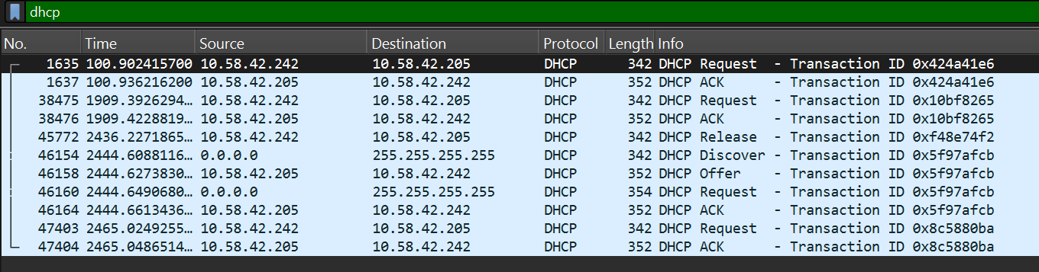
To capture and observe the DHCP process, open Wireshark and start capturing packets on your active network interface such as Wi-Fi or Ethernet. In the display filter bar, type dhcp so that only DHCP-related packets are shown. To generate DHCP traffic, open the Command Prompt on your computer and use the commands ipconfig /release followed by ipconfig /renew. The ipconfig /release command removes the current IP address assigned to the system, forcing the device to disconnect from its existing network configuration. After that, the ipconfig /renew command asks the network for a new IP address from the DHCP server. During this process, Wireshark captures the four important DHCP messages that form the communication process of Dynamic Host Configuration Protocol. First, the client sends a DHCP Discover message as a broadcast to find available DHCP servers on the network. Next, the DHCP server replies with a DHCP Offer, which contains an available IP address and other network configuration details such as subnet mask and gateway. The client then sends a DHCP Request message indicating that it accepts the offered IP address from the server. Finally, the server responds with a DHCP Acknowledge (ACK) message confirming the allocation of the IP address to the client. Once this acknowledgement is received, the client configures the assigned IP address and can begin communicating with other devices on the network. This sequence of Discover, Offer, Request, and Acknowledge is commonly known as the DORA process in DHCP.
5) Given an IP address range of 192.168.1.0/24, divide the network into 4 subnets.
To divide the network 192.168.1.0/24 into 4 subnets, we use the concept of Subnetting. A /24 network has 256 IP addresses (from 192.168.1.0 to 192.168.1.255). To create 4 subnets, we must borrow 2 bits from the host portion because (2^2 = 4). After borrowing these bits, the new subnet prefix becomes /26. The new subnet mask is 255.255.255.192. Each subnet now contains 64 IP addresses (256 ÷ 4 = 64), out of which 62 are usable host addresses because one address is reserved for the network address and one for the broadcast address.
The first subnet is 192.168.1.0/26. The network address is 192.168.1.0, the valid host range is 192.168.1.1 – 192.168.1.62, and the broadcast address is 192.168.1.63. The second subnet is 192.168.1.64/26, where the network address is 192.168.1.64, the valid host range is 192.168.1.65 – 192.168.1.126, and the broadcast address is 192.168.1.127. The third subnet is 192.168.1.128/26, with network address 192.168.1.128, valid hosts 192.168.1.129 – 192.168.1.190, and broadcast address 192.168.1.191. The fourth subnet is 192.168.1.192/26, where the network address is 192.168.1.192, the valid host range is 192.168.1.193 – 192.168.1.254, and the broadcast address is 192.168.1.255. By performing this calculation, the original /24 network is successfully divided into four equal subnets, each capable of supporting 62 devices.
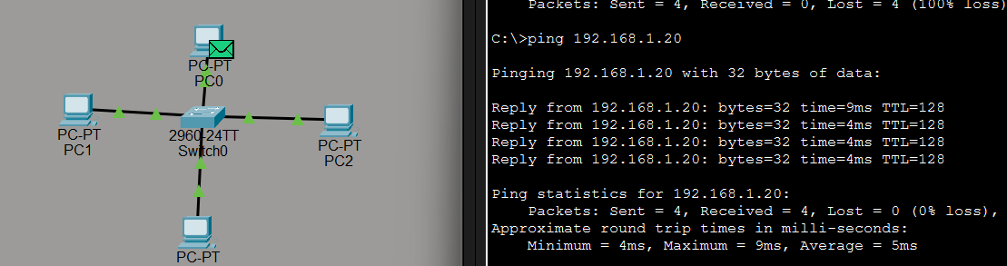
The network 192.168.1.0/24 was divided into four subnets by borrowing two bits from the host portion, resulting in a new subnet mask of 255.255.255.192 (/26). Each subnet contains 64 IP addresses with 62 usable host addresses. IP addresses from these subnets were assigned to devices in Cisco Packet Tracer. After configuring the IP settings, connectivity between the devices was tested using the ping command, and successful replies confirmed that the subnet configuration was working correctly.
6) You are given three IP addresses: 10.1.1.1, 172.16.5.10, and 192.168.1.5.Task: Identify the class of each IP address (Class A, B, or C). What is the default subnet mask for each class? Provide the range of IP addresses for each class.
The IP address 10.1.1.1 belongs to Class A because its first octet is between 1 and 126, and its default subnet mask is 255.0.0.0. The IP address 172.16.5.10 belongs to Class B because its first octet lies between 128 and 191, and its default subnet mask is 255.255.0.0. The IP address 192.168.1.5 belongs to Class C since its first octet falls between 192 and 223, and its default subnet mask is 255.255.255.0. Each class has a different range of IP addresses and subnet mask used to organize networks.
7) In Cisco Packet Tracer, create a small network with multiple devices (e.g., 2 PCs and a router). Use private IP addresses (e.g., 192.168.1.x) on the PCs and configure the router to perform NAT to allow the PCs to access the internet.
Task: Test the NAT configuration by pinging an external IP address from the PCs and capture the traffic using Wireshark.
What is the source IP address before and after NAT?
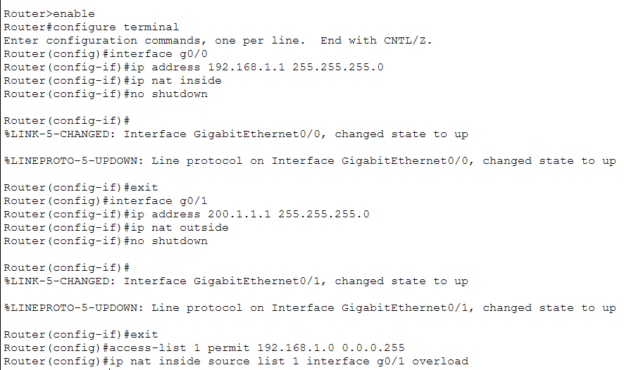
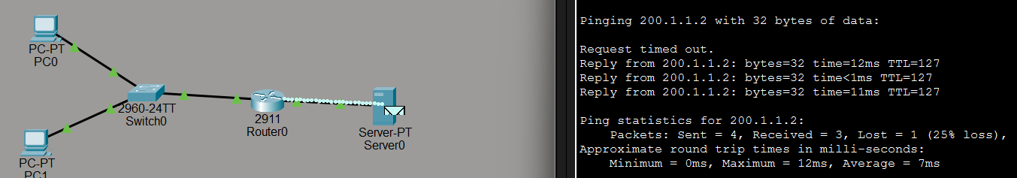
In this network, two PCs were configured with private IP addresses (192.168.1.x). A router was configured to perform Network Address Translation so that internal devices could communicate with an external network. When a PC sends a packet to the external server, the packet initially contains the private IP address of the PC as the source. The router then translates this private IP address into its public IP address before forwarding the packet to the internet. Therefore, the source IP address before NAT is the private IP of the PC (192.168.1.x), and after NAT it becomes the public IP address of the router (200.1.1.1).

